V. Greenland Data Sets

A. Flight 6 Segment 1 – outlet glacier, summer, surface (Figure 3) Easting orgin = 550000. Northing orgin = 7675000.
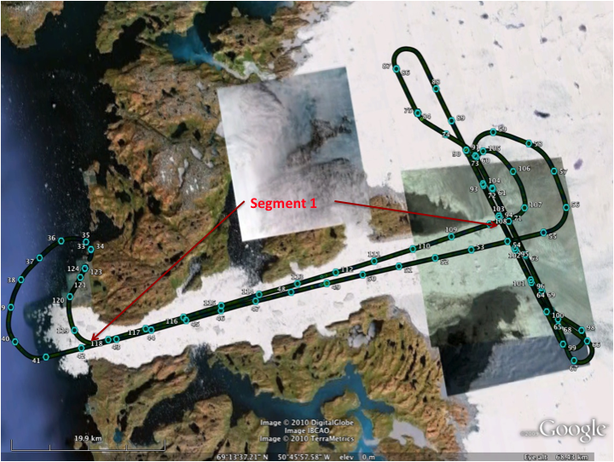
.
Figure 3 - Flight 6 aircraft Groundtrack – Segment 1 is between the arrow heads.

This section spans the outlet of the Jacobshavn Glacier and the floating ice in the fjord. A georeferenced data base was created with just the segment 1 data selected by time. Though data from other portions of the flight overflew the same area, additional data was not used since the geolocation of each pass was not accurate enough to combine two separate portions of the same flight without causing elevation errors of several meters. We created the following data sets:

- “Ground Truth” data set using as described in II.C file format A.
  - Greenld_Flight6_Seg01-0_Db001_Cap5.00_F1_R0_Msp9999_i0_Ns0000.V02 (Figure 4a)
- Signal and Noise simulated ICESat-2 data for the three different power levels, to simulate the center, side, and corner beams. This used the signal only data sets and algorithms described in II.D, E, and F with simulated noise; the mean noise rate = 5.16E+06 MHz, File Format B.
  - Greenld_Flight6_Seg01-0_Dball_Cap3.00_F0_R1_Msp2.70_i0_Ns5.16.V02; (Mean number of photons/shot = 2.70943) (Figure 4b)
  - Greenld_Flight6_Seg01-0_Dball_Cap3.00_F0_R1_Msp1.35_i0_Ns5.16.V02; (Mean number of photons/shot = 1.35472) (Figure 4c)
  - Greenld_Flight6_Seg01-0_Dball_Cap3.00_F0_R1_Msp0.67_i0_Ns5.16.V02; (Mean number of photons/shot =0.677358) (Figure 4d).

Figure 2 corner beam Portion of Flight 6 Segment 1; a- ground truth data, b- center beam with noise, c-side beam with noise, d- corner beam with noise
B. Flight 7 – segments 6 and 7 (Figure 5) , ice sheet interior, summer surfaces Easting orgin = 550000. Northing orgin = 7675000.

These segment were collected north of the Jacobshavn Glacier in relatively slow-moving ice near the Swiss Camp research station. Need to show segments 6 and 7, and Swiss camp location. Two georeferenced data bases were created, one with just the segment 6 data selected by time, and one with just segment 7. Though the data from these segments overlap the same area, the geolocation was not accurate enough to combine the two separate portions of the same flight without causing elevation errors of several meters. We created the following data sets:

- Two “Ground Truth” data sets using algorithms described in II.C file format A:
  - Greenld_Flight7_Seg06-0_Db006_Cap5.00_F1_R0_Msp9999_i0_Ns0000.V02
  - Greenld_Flight7_Seg07-0_Db007_Cap5.00_F1_R0_Msp9999_i0_Ns0000.V02
- Signal and Noise data for the three different power levels of the center, side, and corner respectively. This used the algorithms described in II.D, E, and F: mean noise rate = 6.83E+06 MHz, file Format B.

  - Greenld_Flight7_Seg06-0_Db006_Cap3.00_F0_R1_Msp2.04_i0_Ns6.83.V02 (mean photons/shot=2.04605)
  - Greenld_Flight7_Seg07-0_Db007_Cap3.00_F0_R1_Msp2.04_i0_Ns6.83.V02
(mean photons/shot=2.04605)
  - Greenld_Flight7_Seg06-0_Db006_Cap3.00_F0_R1_Msp4.09_i0_Ns6.83.V02
(mean photons/shot=4.09209)
  - Greenld_Flight7_Seg07-0_Db007_Cap3.00_F0_R1_Msp4.09_i0_Ns6.83.V02 (mean photons/shot=4.09209)
  - Greenld_Flight7_Seg06-0_Db006_Cap3.00_F0_R1_Msp8.18_i0_Ns6.83.V02 (mean photons/shot=8.18418)
  - Greenld_Flight7_Seg07-0_Db007_Cap3.00_F0_R1_Msp8.18_i0_Ns6.83.V02(mean photons/shot=8.18418)

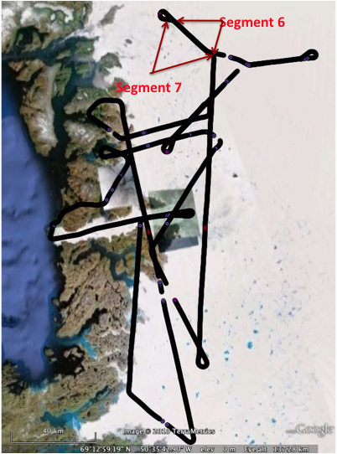

Figure 5 - Segments 6 and 7 for Flight 7
VI. Vegetation Region Data Sets
The Sigma micropulse laser was flown over three vegetation regions in October 2009 during leaf-on conditions in each region; The Smithsonian Environmental Research Center (SERC), and the Pine Barren regions of Silas Little and Cedar Bridge. One georeferenced data base was created for each of the 3 regions and 5 straight line segments were selected (Figure 6) from which to create “ground truth” and ICESat-2 simulated data sets. Note that even though the aircraft ground track contains crossovers during each flight, we did not separate the data for each segment into separate databases like we did for the Greenland flights. Therefore, there may be noise in the elevations due to geolocation errors where these crossovers exist.

A. SERC region-X-Easting origin UTM = 365477. Y-Northing origin UTM= 4305813.

- Ground Truth Files – Format A, one for each of the 5 segments
  - SERC---_Flight1_Seg01-0_Dball_Cap5.00_F1_R0_Msp9999_i0_Ns0000.V02
  - SERC---_Flight1_Seg02-0_Dball_Cap5.00_F1_R0_Msp9999_i0_Ns0000.V02
  - SERC---_Flight1_Seg03-0_Dball_Cap5.00_F1_R0_Msp9999_i0_Ns0000.V02
  - SERC---_Flight1_Seg04-0_Dball_Cap5.00_F1_R0_Msp9999_i0_Ns0000.V02
  - SERC---_Flight1_Seg05-0_Dball_Cap5.00_F1_R0_Msp9999_i0_Ns0000.V02

- ICESat-2 simulated files - Format B
  - Case 8b, Temperate hilly, 90% canopy closure, noise= 1.4379E6 photons/sec. The noise rate and the mean # of photons per shot were linearly interpolated from Tony’s spreadsheet from the min (10% closure) and max (99% closure) values.

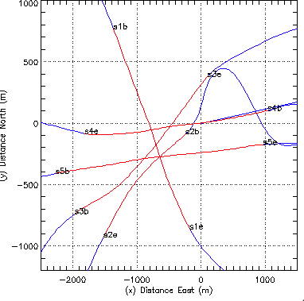
    - Corner Beam, mean # of photons/shot = 0.483471769
Figure 6-SERC data segments in red, aircraft flight lines in blue, snb-segment beginning, sne-segment end
      - SERC---_ Flight1_Seg01-0_Dball_Cap1.00_F0_R1_Msp0.48_i0_Ns1.44.V0
      - SERC---_ Flight1_Seg02-0_Dball_Cap1.00_F0_R1_Msp0.48_i0_Ns1.44.V02 SERC---_Flight1_Seg03-0_Dball_Cap1.00_F0_R1_Msp0.48_i0_Ns1.44.V02
      - SERC---_Flight1_Seg04-0_Dball_Cap1.00_F0_R1_Msp0.48_i0_Ns1.44.V02
      - SERC---_Flight1_Seg05-0_Dball_Cap1.00_F0_R1_Msp0.48_i0_Ns1.44.V02
    - Side Beam, mean # of photons/shot= 0.966944208
      - SERC---_Flight1_Seg01-0_Dball_Cap1.00_F0_R1_Msp0.96_i0_Ns1.44.V02
      - SERC---_Flight1_Seg02-0_Dball_Cap1.00_F0_R1_Msp0.96_i0_Ns1.44.V02
      - SERC---_Flight1_Seg03-0_Dball_Cap1.00_F0_R1_Msp0.96_i0_Ns1.44.V02
      - SERC---_Flight1_Seg04-0_Dball_Cap1.00_F0_R1_Msp0.96_i0_Ns1.44.V02
      - SERC---_Flight1_Seg05-0_Dball_Cap1.00_F0_R1_Msp0.96_i0_Ns1.44.V02
    - Center Beam, mean # of photons/shot= 1.93388491
      - SERC---_Flight1_Seg01-0_Dball_Cap1.00_F0_R1_Msp1.93_i0_Ns1.44.V02
      - SERC---_Flight1_Seg02-0_Dball_Cap1.00_F0_R1_Msp1.93_i0_Ns1.44.V02
      - SERC---_Flight1_Seg03-0_Dball_Cap1.00_F0_R1_Msp1.93_i0_Ns1.44.V02
      - SERC---_Flight1_Seg04-0_Dball_Cap1.00_F0_R1_Msp1.93_i0_Ns1.44.V02
      - SERC---_Flight1_Seg05-0_Dball_Cap1.00_F0_R1_Msp1.93_i0_Ns1.44.V02

(2) Cedar Bridge (Pine Barren) Data Sets: (case 9a, boreal flat)
x-Easting orgin = 553665. y-Northing orgin = 4410526.

- Ground truth data sets – Format A, one for each of the 6 segments (see Figure 7)
1.1 PineBar_CedarBr_Seg01-0_Dball_Cap5.00_F1_R0_Msp9999_i0_Ns0000.V02
1.2 PineBar_CedarBr_Seg02-0_Dball_Cap5.00_F1_R0_Msp9999_i0_Ns0000.V02
1.3 PineBar_CedarBr_Seg03-0_Dball_Cap5.00_F1_R0_Msp9999_i0_Ns0000.V02 t
1.4 PineBar_CedarBr_Seg04-0_Dball_Cap5.00_F1_R0_Msp9999_i0_Ns0000.V02
1.5 PineBar_CedarBr_Seg05-0_Dball_Cap5.00_F1_R0_Msp9999_i0_Ns0000.V02
1.6 PineBar_CedarBr_Seg06-0_Dball_Cap5.00_F1_R0_Msp9999_i0_Ns0000.V02
2.0 ICESat-II simulated data sets – Format B using 75% canopy closure, noise and mean # of photons linearly extrapolated from min (10% closure) and max (60% closure) on Tony’s spreadsheet-Noise= 1.4582E+06
2.1Corner Beam - Mean # of photons/shot = 0.48243055
    - PineBar_CedarBr_Seg01-0_Dball_Cap1.00_F0_R1_Msp0.48_i0_Ns1.46.V02
    - PineBar_CedarBr_Seg02-0_Dball_Cap1.00_F0_R1_Msp0.48_i0_Ns1.46.V02
    - PineBar_CedarBr_Seg03-0_Dball_Cap1.00_F0_R1_Msp0.48_i0_Ns1.46.V02
    - PineBar_CedarBr_Seg04-0_Dball_Cap1.00_F0_R1_Msp0.48_i0_Ns1.46.V02 PineBar_CedarBr_Seg05-0_Dball_Cap1.00_F0_R1_Msp0.48_i0_Ns1.46.V02
    - PineBar_CedarBr_Seg06-0_Dball_Cap1.00_F0_R1_Msp0.48_i0_Ns1.46.V02
  - Side Beam - Mean # of photons/shot = 0.96486167
    - PineBar_CedarBr_Seg01-0_Dball_Cap1.00_F0_R1_Msp0.96_i0_Ns1.46.V02 PineBar_CedarBr_Seg02-0_Dball_Cap1.00_F0_R1_Msp0.96_i0_Ns1.46.V02
    - PineBar_CedarBr_Seg03-0_Dball_Cap1.00_F0_R1_Msp0.96_i0_Ns1.46.V02
    - PineBar_CedarBr_Seg04-0_Dball_Cap1.00_F0_R1_Msp0.96_i0_Ns1.46.V02
    - PineBar_CedarBr_Seg05-0_Dball_Cap1.00_F0_R1_Msp0.96_i0_Ns1.46.V02
    - PineBar_CedarBr_Seg06-0_Dball_Cap1.00_F0_R1_Msp0.96_i0_Ns1.46.V02
  - Center Beam - Mean # of photons/shot = 1.9297273
    - PineBar_CedarBr_Seg01-0_Dball_Cap1.00_F0_R1_Msp1.92_i0_Ns1.46.V02
    - PineBar_CedarBr_Seg02-0_Dball_Cap1.00_F0_R1_Msp1.92_i0_Ns1.46.V02
    - PineBar_CedarBr_Seg03-0_Dball_Cap1.00_F0_R1_Msp1.92_i0_Ns1.46.V02
    - PineBar_CedarBr_Seg04-0_Dball_Cap1.00_F0_R1_Msp1.92_i0_Ns1.46.V02
    - PineBar_CedarBr_Seg05-0_Dball_Cap1.00_F0_R1_Msp1.92_i0_Ns1.46.V02
    - PineBar_CedarBr_Seg06-0_Dball_Cap1.00_F0_R1_Msp1.92_i0_Ns1.46.V02

(3) Silas Little- (Pine Barren) Data Sets: (case 9a, boreal flat)
x-Easting orgin = 534094. y- Northing orgin = 4418121.
  - Ground truth data sets – Format A, one for each of the 9 segments (see Figure 8):
PineBar_SilasLi_Seg01-0_Dball_Cap5.00_F1_R0_Msp9999_i0_Ns0000.V02
PineBar_SilasLi_Seg02-0_Dball_Cap5.00_F1_R0_Msp9999_i0_Ns0000.V02
PineBar_SilasLi_Seg03-0_Dball_Cap5.00_F1_R0_Msp9999_i0_Ns0000.V02
PineBar_SilasLi_Seg04-0_Dball_Cap5.00_F1_R0_Msp9999_i0_Ns0000.V02
PineBar_SilasLi_Seg05-0_Dball_Cap5.00_F1_R0_Msp9999_i0_Ns0000.V02
PineBar_SilasLi_Seg06-0_Dball_Cap5.00_F1_R0_Msp9999_i0_Ns0000.V02
PineBar_SilasLi_Seg07-0_Dball_Cap5.00_F1_R0_Msp9999_i0_Ns0000.V02
PineBar_SilasLi_Seg08-0_Dball_Cap5.00_F1_R0_Msp9999_i0_Ns0000.V02
PineBar_SilasLi_Seg09-0_Dball_Cap5.00_F1_R0_Msp9999_i0_Ns0000.V02
  - ICESat-2 simulated data sets – Format B using 75% canopy closure, noise and mean # of photons linearly extrapolated from min (10% closure) and max (60% closure) on Tony’s spreadsheet-Noise= 1.4582E+06

    - Corner Beam - Mean # of photons/shot = 0.48243055
      - PineBar_SilasLi_Seg01-0_Dball_Cap1.00_F0_R1_Msp0.48_i0_Ns1.46.V02
      - PineBar_SilasLi_Seg02-0_Dball_Cap1.00_F0_R1_Msp0.48_i0_Ns1.46.V02
      - PineBar_SilasLi_Seg03-0_Dball_Cap1.00_F0_R1_Msp0.48_i0_Ns1.46.V02
      - PineBar_SilasLi_Seg04-0_Dball_Cap1.00_F0_R1_Msp0.48_i0_Ns1.46.V02
      - PineBar_SilasLi_Seg05-0_Dball_Cap1.00_F0_R1_Msp0.48_i0_Ns1.46.V02
      - PineBar_SilasLi_Seg06-0_Dball_Cap1.00_F0_R1_Msp0.48_i0_Ns1.46.V02
      - PineBar_SilasLi_Seg07-0_Dball_Cap1.00_F0_R1_Msp0.48_i0_Ns1.46.V02
      - PineBar_SilasLi_Seg08-0_Dball_Cap1.00_F0_R1_Msp0.48_i0_Ns1.46.V02
      - PineBar_SilasLi_Seg09-0_Dball_Cap1.00_F0_R1_Msp0.48_i0_Ns1.46.V02
    - Side Beam - Mean # of photons/shot = 0.96486167
      - PineBar_SilasLi_Seg01-0_Dball_Cap1.00_F0_R1_Msp0.96_i0_Ns1.46.V02
      - PineBar_SilasLi_Seg02-0_Dball_Cap1.00_F0_R1_Msp0.96_i0_Ns1.46.V02
      - PineBar_SilasLi_Seg03-0_Dball_Cap1.00_F0_R1_Msp0.96_i0_Ns1.46.V02
      - PineBar_SilasLi_Seg04-0_Dball_Cap1.00_F0_R1_Msp0.96_i0_Ns1.46.V02
      - PineBar_SilasLi_Seg05-0_Dball_Cap1.00_F0_R1_Msp0.96_i0_Ns1.46.V02
      - PineBar_SilasLi_Seg06-0_Dball_Cap1.00_F0_R1_Msp0.96_i0_Ns1.46.V02
      - PineBar_SilasLi_Seg07-0_Dball_Cap1.00_F0_R1_Msp0.96_i0_Ns1.46.V02
      - PineBar_SilasLi_Seg08-0_Dball_Cap1.00_F0_R1_Msp0.96_i0_Ns1.46.V02
      - PineBar_SilasLi_Seg09-0_Dball_Cap1.00_F0_R1_Msp0.96_i0_Ns1.46.V02
    - Center Beam - Mean # of photons/shot = 1.9297273
      - PineBar_SilasLi_Seg01-0_Dball_Cap1.00_F0_R1_Msp1.92_i0_Ns1.46.V02
      - PineBar_SilasLi_Seg02-0_Dball_Cap1.00_F0_R1_Msp1.92_i0_Ns1.46.V02
      - PineBar_SilasLi_Seg03-0_Dball_Cap1.00_F0_R1_Msp1.92_i0_Ns1.46.V02
      - PineBar_SilasLi_Seg04-0_Dball_Cap1.00_F0_R1_Msp1.92_i0_Ns1.46.V02
      - PineBar_SilasLi_Seg05-0_Dball_Cap1.00_F0_R1_Msp1.92_i0_Ns1.46.V02
      - PineBar_SilasLi_Seg06-0_Dball_Cap1.00_F0_R1_Msp1.92_i0_Ns1.46.V02
      - PineBar_SilasLi_Seg07-0_Dball_Cap1.00_F0_R1_Msp1.92_i0_Ns1.46.V02
      - PineBar_SilasLi_Seg08-0_Dball_Cap1.00_F0_R1_Msp1.92_i0_Ns1.46.V02
      - PineBar_SilasLi_Seg09-0_Dball_Cap1.00_F0_R1_Msp1.92_i0_Ns1.46.V02

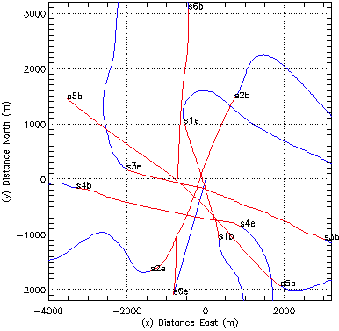
Figure 5 - Cedar Bridge segments in red, airplane flight path in blue
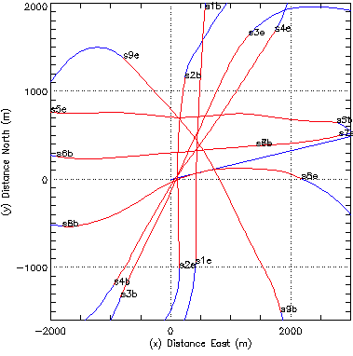
Figure 6 Silas Little segments in red, airplane flight path in blue

